Seneca County Welcome Home Ohio Housing Program-APPLICATION PACKET
Thank you for your interest in the Seneca County Welcome Home Ohio Program. This initiative, funded by the Ohio Department of Development, aims to help qualified individuals and families achieve homeownership through the construction and sale of 5 new homes in Fostoria. The five homes, located at 1310, 1326, 1322, 1318, and 1314 Walnut Street, will be sold to income-qualified buyers for no more than $180,000 each. We anticipate between $140,000 and $160,000. You must complete the application to be eligible to make an offer. We encourage all income qualified individuals to complete an application.

Eligibility Requirements
Eligible individuals must meet ALL of the following criteria:
- Have an annual income at or below 80% of the area median income (AMI). See income limits table on page 2.
- Demonstrate the financial means to purchase the residential property.
- Agree to maintain ownership of the property, occupy it as a primary residence, and not rent any portion of it for at least five years after purchase.
- Agree not to sell the property for 20 years after purchase to a buyer/household with an income greater than 80% of the AMI.
- Agree that the Director of Development is a third-party beneficiary of the purchase agreement.
- Agree to pay any applicable penalties if ownership and occupancy requirements are not maintained.
- Participate in program-provided pre- or post-purchase financial literacy and counseling.
- Verify owner-occupied status annually for five years with the Seneca County Land Bank.
- Submit a current, valid pre-approval letter from a recognized bank or mortgage lender confirming the applicant’s financial ability to complete the home purchase. (see page 3 for a list of Seneca County Welcome Home Ohio Program partner banks)

Application Instructions
To determine eligibility, applicants must complete the attached financial disclosure documents and submit them in a sealed envelope, along with a bank pre-approval letter, and other supporting financial documents requested, to the Seneca County Land Bank no later than December 12, 2025, to the Seneca County Land Bank, via mail or in person to Fostoria Economic Development, 342 Perry St. Fostoria, OH 44830.

If you need assistance obtaining a pre-approval, please refer to the list of Seneca County Welcome Home Ohio partner banks offering mortgage lending programs and homebuyer down payment assistance.

Application Review
Applications will be scored and reviewed based on:
- Completeness and accuracy
- Demonstrated financial means to purchase and maintain the property

Important Notice
Meeting eligibility requirements and submitting a complete application does not guarantee the right to purchase a Welcome Home Ohio residential property. The final selection of home purchasers will be made at the sole discretion of the Seneca County Land Bank.

The Seneca County Land Bank reserves the right to reject any incomplete or inaccurate applications.

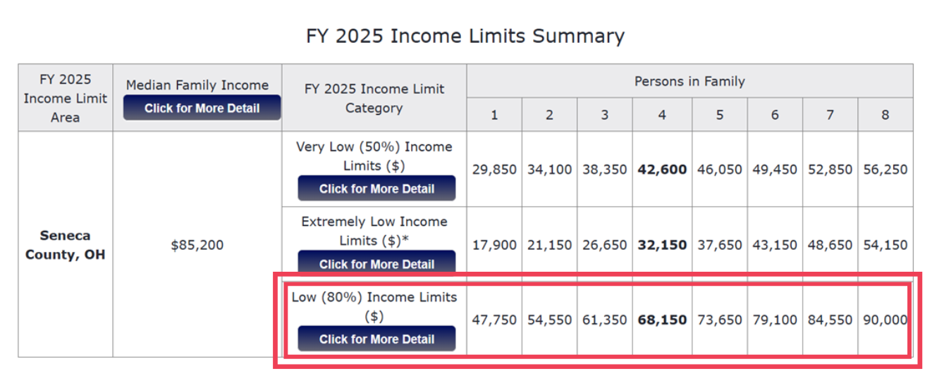
The Welcome Home Ohio income limits are based on HUD numbers. FY 2025 Income Limits Summary table may also be found, https://www.huduser.gov/portal/datasets/il.html.

Income limits for the Seneca County Welcome Home Ohio program are based on household income. Household income is based upon all adult earner income, 18 years and older, currently living in the home.

Seneca County Welcome Home Ohio Partner Banks:

Croghan Colonial Bank
796 W Market St
Tiffin, Ohio
(419) 447-2250

48 E Market St,
Tiffin, OH 44883
(419) 447-8777

Premier Bank
1694 N. Countyline St.
Fostoria, OH 44830
(419) 436-1310
Sutton Bank
719 W Market St
Tiffin, OH 44883
(419) 448-9000

1 S. Main St.
Attica, OH 44807
(419) 426-3641

Old Fort Bank
634 W Market St
Tiffin, OH 44883
(419) 447-1600

33 E Market St
Tiffin, OH 44883
(419) 447-4790

599 Plaza Dr
Fostoria, OH 44830
(419) 436-1425

* The banks listed above are project partners and may offer special financing options to qualifying applicants. Applicants/Purchasers may use any financial institution of their choice. Use of a Seneca County Welcome Ohio partner bank does not impact qualification or application status.

Seneca County Welcome Home Ohio Applicant Checklist

Eligibility Requirements
☐ Annual household income is at or below 80% AMI (verify with current HUD income limits)
☐ Will use the home as a primary residence and agree to:
☐ • Live in the home for at least 5 years
☐ • Not rent any portion of the home
☐ • Not sell to a buyer over 80% AMI for 20 years
☐ • Designate Director of Development as third-party beneficiary
☐ Will participate in required financial literacy or counseling
☐ Agree to annual owner-occupancy verification for 5 years
☐ Understand and accept penalty clauses for noncompliance

REQUIRED DOCUMENTS
☐ Completed Homebuyer Application
☐ Bank or mortgage lender pre-approval letter
☐ Proof of income for all household members age 18+ (last 2 month’s stubs or benefit letters)
☐ Last 6 months bank statements (example: April -September 2025 or May-October 202)
☐ Utility bills (1 month’s worth for each type)
☐ Homeowner’s insurance declaration page (if applicable)
☐ Mortgage information (if currently owned)
☐ Documentation of assets and interest income
☐ Signed HOME Program Eligibility Release Form (all adults)
☐ Signed Financial Privacy Statement (applicant and co-applicant)

APPLICATION FORM
☐ Completed personal and household member information
☐ Listed income sources and amounts for each household member age 18+
☐ Listed other income (Social Security, child support, pension, etc.)
☐ Declared any owned real estate outside of primary residence
☐ Indicated current housing type and ownership status
☐ Provided all monthly household expenses
☐ Declared any assets disposed of in the past 24 months
☐ Indicated any conflicts of interest with city/county officials

SUBMISSION INSTRUCTIONS
☐ Application and documents placed in a sealed envelope
☐ Submitted by the deadline, December 12, 2025 to:
Fostoria Economic Development Corp, 342 Perry St, Fostoria, OH 44830

SENECA COUNTY WELCOME HOME OHIO
HOMEBUYER APPLICATION
(Please be sure to answer ALL questions and provide dollar amounts.)
PRIMARY APPLICANT NAME: ________________________________ PHONE: _____________________
MAILING ADDRESS: ______________________________________________________________________
CITY: __________________________ ZIP: ________________ COUNTY:______________________
ADDRESS FOR ASSISTANCE: ______________________________________________________________
Would you like to be contacted by E-mail?: YES NO E-mail Address:______________________________
HOUSEHOLD MEMBERS (All persons currently living in the home including children under age 18.)
 | Primary Applicant | Household  Member # 2 | Household  Member # 3 | Household  Member # 4 | Household  Member # 5 | Household  Member #6
Social Sec. Number
Last Name
First Name
Relationship to Applicant | -Self-
Date of Birth
Sex
Disabled (yes or no)
Race: Amer.Indian/Alasaka Asian, Black/African Amer., Multi, Nat.Hawaiian/Pacific Islander, Other , White
Ethnicity
Hispanic/Latin or not
Level of Education
Veteran (yes or no)
Health Insurance
(yes or no)
Income Source(s)

INCOME SOURCES – (Proof of income must be provided with copies of last 4 pay stubs. Include all benefit letters from SS, child support, pension, unemployment, alimony, etc. for all household members age 18 and over)
Primary Applicant | Household Member #2

Employer: |  | Employer
Address: |  | Address
Occupation: |  | Occupation
Employment Start Date: | Monthly Salary: $ | Employment Start Date: | Monthly Salary: $

Household Member #3 | Household Member #4

Employer |  | Employer
Address |  | Address
Occupation |  | Occupation
Employment Start Date: | Monthly Salary: $ | Employment Start Date: | Monthly Salary: $
Household Member #5 |  | Household Member #6
Employer |  | Employer
Address |  | Address
Occupation |  | Occupation
Employment Start Date: | Monthly Salary: $ | Employment Start Date: | Monthly Salary: $

OTHER INCOME SOURCES- Be sure to answer ALL questions and dollar amounts:
Do you receive ADC, OWF, TANF or other public/cash assistance? YES ____ NO ____
If yes, what is the monthly amount $__________ Annual Amount $__________
Do you receive Unemployment Benefits? YES ____ NO ____
If yes, what is your weekly amount $ _________ Annual Amount $ _________
Do you receive Social Security? YES ____ NO ____
If yes, what is the monthly amount $__________ Annual Amount $__________
Do you receive a Pension? YES ____ NO ____
If yes, what is the monthly amount $__________ Annual Amount $__________
Do you receive Child Support? YES ____ NO ____ If yes, what is the monthly amount $__________ Annual Amount $__________
Do you receive Alimony? YES ____ NO ____
If yes, what is the monthly amount $__________ Annual Amount $__________
Do you receive Rental Income? YES ____ NO ____
If yes, what is the monthly amount $_________ Annual Amount $________
Do you receive any other income not listed above? YES ____ NO ____
If yes, Please explain the type of income along with the monthly and annual amounts: ______________________
____________________________________________________________________________________________
Do you own real estate/property(s) other than your primary residence? YES ____ NO ____
If yes, provide the total dollar equity amount of all property(s) $__________
Do you live in a single family, mobile home, or multifamily home? SINGLE____ MH____ MULTI_____
Do you own, rent or have a land contract? RENT_____ OWN_____ LANDCONTRACT_____
If you own a mobile home, was the mobile home constructed on or before June 15, 1976? YES___ NO ____
MONTHLY HOUSEHOLD EXPENSES (Attach a copy of one month’s utility bills)
Type | YES | NO | Monthly $ | Company | Type | YES | NO | Monthly $ | Company
Mortgage/Rent |  |  |  |  | Gas
2nd Mortgage |  |  |  |  | Electric
Property Tax |  |  |  |  | Water/Sewer
Home Insurance |  |  |  |  | Trash

GLCAP Office Use Only: Total Monthly income $________ Total Monthly Expenses $________ Housing Cost %______
INSURANCE INFORMATION (Attach a copy of your declaration page)
Amount of Insurance on Home | $ | Insurance Agent
Insurance Agent’s Phone No. |  | Address

MORTGAGE INFORMATION (Primary Residence)
First Mortgage |  | Second Mortgage
Mortgage Lender |  | Mortgage Lender
Original Amount | $ | Original Amount | $
Balance Owed | $ | Balance Owed | $
Monthly Payment | $ | Monthly Payment | $

ASSETS/INTEREST INCOME: List ALL Accounts/assets for all household members age 18 & over; See pg. 4
Type of Account | Bank/ Institution | Amount |  | Household Member
Checking 1
Checking 2
Checking 3
Savings 1
Savings 2
Savings 3
Certificate of Deposit
Cash Value of a Life Insurance
IRA
Money Market
Retirement
Other

Have you disposed of more than $1000 in Assets in the past 2- years (24 months)?
(For a list of inclusions and exclusions see the back of this page) YES_____ NO______

Are you or any other household member(s) related to an employee, agent, consultant, officer, elected official, or an appointed official of the city/ county in which you are applying for assistance? YES_____ NO______
If yes, please give their name, title, and employer: _________________________________________________________
Pursuant to 24 CFR 570.489 (h)

I hereby certify that the information provided in this application is true and complete to the best of my knowledge. I hereby give GLCAP & Seneca County Land Bank permission to verify all information contained in this application.

_______________________________ __________________________________
Date Applicant

_______________________________ ___________________________________
Date Co-Applicant

Return application in a sealed envelope to:

SENECA COUNTY LANDBANK C/O FEDC

342 PERRY ST.
FOSTORIA, OH 44830

Warning: Title 18, Section 1001 of the U.S. Code states that a person is guilty of a felony for knowingly and willingly making false or fraudulent statements to any department of the United States Government.
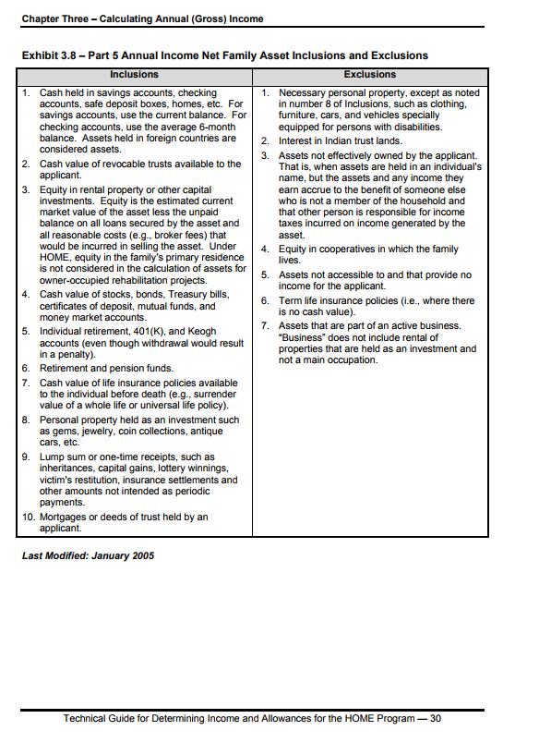

HOME Program Eligibility Release Form

Purpose: Your signature on this HOME Program Eligibility Release Form, and the signatures of each member of your household who is 18 years of age or older, authorizes the above –named organization to obtain information from a third party relative to your eligibility and continued participation in the: HOME Homebuyer Program, Home Rental Rehabilitation Program, HOME Homeowner Rehabilitation Program, and the CDBG Home Building Repair Program.

Privacy Act Notice Statement: WSOS Community Action Commission, Inc. in conjunction with the Department of Housing and Urban Development (HUD) are requiring the collection of the information derived from this form to determine an applicant’s eligibility in a HOME Program and the amount of assistance necessary using HOME funds. This information will be used to establish level of benefit on the HOME Program; to protect the Government’s financial interest; and to verify the accuracy of the information furnished. It may be released to appropriate Federal, State, and local agencies when relevant, to civil, criminal, or regulatory investigators, and to prosecutors. Failure to provide any information may result in a delay or rejection of your eligibility approval. The Department is authorized to ask for this information by the National Affordable Housing Act of 1990.

Instructions: Each adult member of the household must sign a HOME Program Eligibility Release Form prior to the receipt of benefit.

NOTE: THIS GENERAL CONSENT MAY NOT BE USED TO REQUEST A COPY OF A TAX RETURN. IF A COPY OF A TAX RETURN IS NEEDED, IRS FORM 4506, “REQUEST FOR A COPY OF TAX FORM” MUST BE PREPARED AND SIGNED SEPARATELY.

Information Covered: Inquires may be made about the following items: Income (All Sources), Assets (All Sources), Child Care Expenses, Handicap Assistance Expense (If Applicable), and Medical Expense (If Applicable)

Authorization: I authorize the above-named HOME Participating Jurisdiction and HUD to obtain information about me and my household that is pertinent to eligibility for participation in the HOME Program.

I acknowledge that: (1) A Photocopy of this form is as valid as the original. (2) I have the right to review the file and the information received using this form (with a person of my choosing to accompany me. (3) I have the right to copy information from this file and to request correction of information I believe inaccurate. (4) All adult household members will sign this form and cooperate with the owner in this process.

EVERYONE 18 YEARS OR OLDER, IN THE HOUSEHOLD, MUST SIGN AND DATE THIS FORM | PRINTED NAME, SIGNATURE, & DATE
Head of Household – Signature, Printed Name, and Date:
Other Adult Member of the Household – Signature, Printed Name, Date:
Other Adult Member of the Household – Signature, Printed Name, Date:
Other Adult Member of the Household – Signature, Printed Name, Date:

FINANCIAL PRIVACY STATEMENT

This is notice to you as required by the Right to Privacy Act of 1978 that the Department of Housing and Urban Development has the right of access to financial records held by any financial institution in connection with the consideration or administration of the program assistance for which you have applied. Financial records involving your transactions will be available to the Department of Housing and Urban Development without further notice of authorization but will not be disclosed or released to another government agency or department without your consent except as required or permitted by law.

____________ __________________________________
DATE APPLICANT

____________ __________________________________
DATE CO-APPLICANT

FINANCIAL PRIVACY STATEMENT

WARNING: TITLE 18, SECTION 1001 OF THE U.S. CODE STATES THAT A PERSON IS GUILTY OF A FELONY FOR KNOWINGLY AND WILLINGLY MAKING FALSE OR FRAUDULENT STATEMENTS TO ANY DEPARTMENT OF THE UNITED STATES GOVERNMENT.

